Academic Year 2017-2-18 Pay Schedule Adjustment FAQ’s

Who is affected by the adjustments to Academic Pay Schedule?
Faculty and academic professionals paid over 9 months (ACD) are affected. Between the AY2016-17 and AY2017-18 academic years there will be seven pay periods rather than the customary six pay periods, as shown below. Faculty and academic professionals paid over 9 months (ACD) will receive their initial AY2017-18 pay on Friday, September 1, 2017.
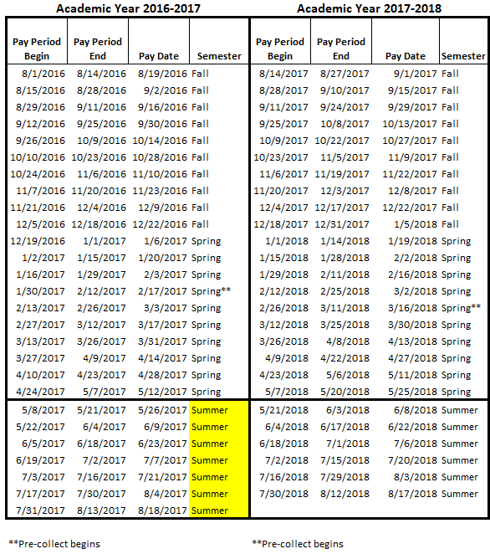

Do I need to do anything?
Faculty and academic professionals paid over 9 months (ACD) have several options in response to the summer 2017 schedule adjustment:
OPTION 1: Take no action. Your final AY2016-17 pay will be received on May 12, 2017 and your first AY2017-18 pay will be received on September 1, 2017.
OPTION 2: Adjust your summer 2017 pay schedule. Faculty and academic professionals on nine month appointments who work all summer can elect to have their summer salary paid over 6 or 7 summer pay periods. Your total summer salary will remain the same, but your bi-weekly rate will be lower if you elect to be paid over 7 pay periods.
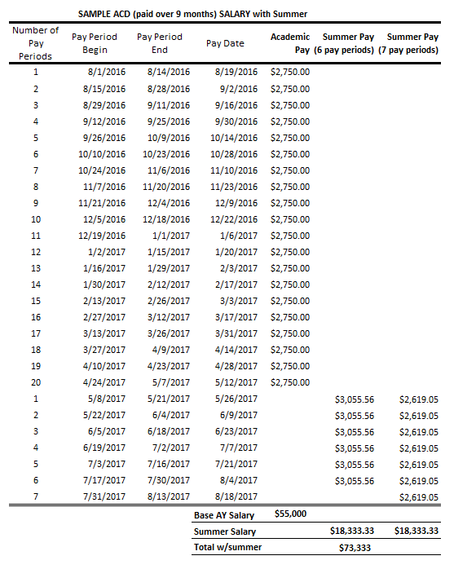

OPTION 3: If eligible, elect the A12 pay option for the 2017-18 academic year. With the A12 pay option, your academic year salary is paid over 26 pay periods from July 1, 2017 to June 30, 2018, rather than over 20 pay periods. The biweekly amount of each paycheck is lower, but total compensation remains the same. For the 2017-18 academic year, the initial A12 pay will be received on July 21, 2017 and the final pay on 7/6/2018.
To elect the A12 pay option, please fill out and return the form to your department by April 30th, 2017. http://www.asu.edu/hr/forms/payopt.pdf
According to ACD 514, faculty and academic professionals who would be ineligible for this option include:
- Faculty receiving pay for fewer than two semesters or less than 50 percent full time equivalent (FTE) and
- Faculty whose pay status changes to fewer than two semesters or whose FTE fall below 50 percent. 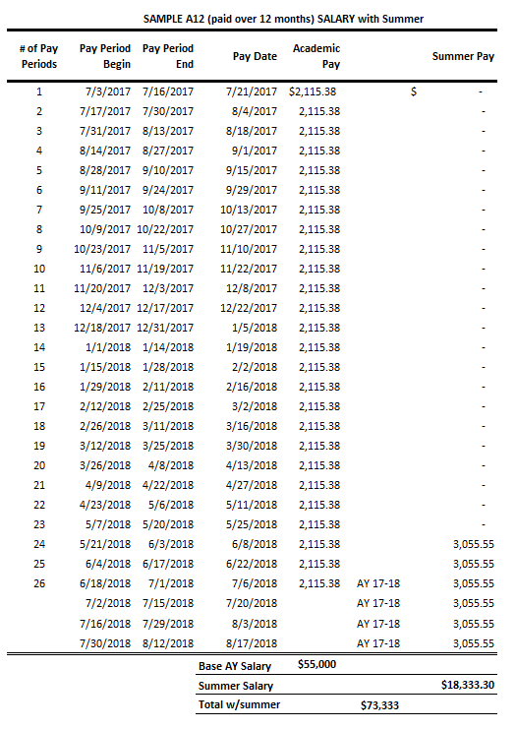
How will this alignment affect my benefits?
Your benefits coverage will not be affected. If you are paid over 9 months (ACD), the pre-collection of benefits for summer 2017 will occur over seven pay periods (instead of six) beginning January 30, 2017.
Is this extended summer schedule adjustment permanent?
No, this schedule adjustment is only for summer 2017. For faculty and academic professionals paid over 9 months (ACD), the number of pay periods between academic years will revert to six beginning in summer 2018.

